04 The Writing Process

Prewriting: Choosing and Narrowing Your Topic

In this lesson you will do the following
- Describe how to________________________________________.
- Determine ____________________________________________.
- Apply a _______________________________________________,

Prewriting: Choosing and Narrowing Your Topic
(2)
In this section you will learn to do the following
- Describe how to ________________________________________.
(3)
As a writer, you need to have a _____________________ of what a written work will ________________ before you begin putting sentences and paragraphs on ________________.
(4)
Writing Modes:

Narrative
Descriptive
Persuasive
Expository
Response to Lit
Investigative
Evaluative
Professional

(5)
Reflexive Writing:
examples:

Extensive Writing:
examples:
(6)
Writing Process
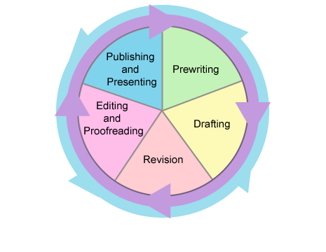
Prewriting:

Drafting:

Revision:

Editing and Proofreading:

Publishing and Presenting:

(10)
The beginning prewriting steps are
- choosing______________________________; and

- narrowing ______________________________.
(11)
Brainstorming:

(12)
Freewriting:

(13)
Blueprinting:

Create your own blueprint in the space below.

(16)
You will want to make sure the ____________________ is ___________________ enough that you can ___________________ it well in a short piece of ___________________.

When you have __________________ the ___________________, it will become the _________________.

Main idea:

(17)
Strategies for narrowing a Topic
Looping:

Step 1:

Step 2:

Step 3:

(18/19)
Web Diagram:

Related Idea:

(20)

In this session, you have learned the following:
- There are many different _________________________________________.
- The writing process involves five steps: ____________________________________________________ ___________________________________________________.
- Reflexive writing is writing you do ________________________; extensive writing is writing _____________________________.
- Prewriting, the first stage in the writing process, includes ___________________________________________________.
- Choosing a topic might include ____________________________________.
- Narrowing a topic might include a __________________________________.

Prewriting: Determining Audience and Purpose and Gathering Details

(2)
In this section you will learn to do the following
- Determine______________________________
(3)
Every type of _______________ has a __________________.

Before you collect information and get ready to write, it is important to consider _______________________________________________.
(4)
audience:

Three good ways to make your writing interesting and effective for your reader.
- Consider the audiences __________________, _________________, ______________________, and _________________ of your subject.
- Be sure the focus of the paper (the main idea) is ____________________ to the audience or explains something the audience ________________________.
- Provide supporting details, or_________________, to explain or emphasize your _______________________.
(5)
Four key questions that can help you decide how to write for an audience:
1.

2.

3.

4.
(9)
editorial:

Three places where editorials may appear :
1.
2.
3.
(10/11)
Read the sample editorial and try to identify
- the main idea: _______________________________________________
- the audience_________________________________________________
- the purpose for writing this piece________________________________
(12/13)
Read the sample journal entry and try to identify
- the main idea: _______________________________________________
- the audience_________________________________________________
- the purpose for writing this piece_________________________________
(15)
There are many different ways to ___________________. You will learn about two helpful methods:
- _________________________
- __________________________
(16)
In writing, an ________________ is a _________________ that is re-created in words.
sensory word bin:
(18)
Another prewriting technique to help you gather details is called ____________________________. This strategy is most helpful when you need to analyze a piece of literature.
(19/20)
Write down the pre-writing prompts in each triangle.
Plot:

Personal allusion:

Theme:

Analysis:

Literary allusion:

Evaluation:

(21)

Summary
In this session, you have learned the following:
- The audience is the______________________________.
- The language and the types of information presented should____________________________________________________.
- The writer can analyze the audience________________________________.
- There are four steps to prewriting:__________________________________ _____________________________________________________________.
- You can use sensory word bin and hexagonal writing strategies ___________ _____________________________________________________.

Prewriting for a Response-to-Literature Essay
(2)
In this section you will learn to do the following
- Apply a prewriting strategy_____________________________________.
(3)
response to literature essay:

(4)
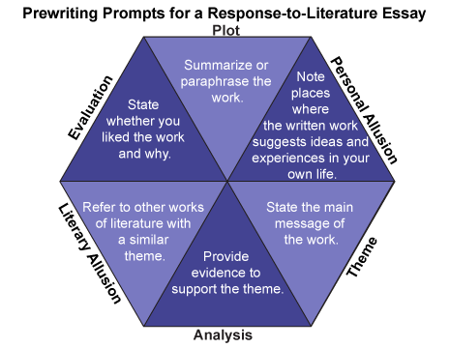
A response-to-literature essay should include the following:
- a reaction to a_______________________________________________.
- a thesis statement that identifies the ______________________________.
- an analysis of the content of the literary work, its related ideas, and _______________________________________________________.
- a focus on one aspect of the work or________________________________.
- an opinion supported with ________________________________________.
(5)
The first prompt in hexagonal writing asks you to _____________________________..
plot:
summary:
paraphrase:
(6)
The second prompt in hexagonal writing asks you to consider ____________________.
personal allusion:
(12)
The third prompt in hexagonal writing asks you to _____________________________.
theme:
(14)
The fourth prompt in hexagonal writing asks you to ____________________________.
theme:
(17)
The fifth prompt in hexagonal writing asks you to ______________________________.
literary allusions:
(19)
The sixth and final prompt in hexagonal writing asks you _______________________.
evaluation:
(22)

Summary
In this session, you have learned the following:
- Use hexagonal writing in the prewriting stage of a _____________________________________________________________.
- Describe the plot by summarizing or paraphrasing the _______________________________________________.
- Provide a personal allusion by noting the________________________________________________________.
- Identify the theme by stating ______________________________________.
- Provide details for analysis by looking for quotations or evidence to __________________________________________________________.
- Include a literary allusion that mentions another ___________________________________________________________.
- Provide an evaluation by noting what was significant or___________________________________________________.

